**OCTO PRINTER IMAGE DOWN LOAD**

<https://octoprint.org/download/>

OCTO PRINTER IMAGE to SD MEMORY WRITE

<https://www.raspberrypi.org/forums/viewtopic.php?t=131489>

<https://www.raspberrypi.org/forums/viewtopic.php?p=890408#p890408>

**RASPBERRY PI FIRMWARE UPDATE**

sudo rpi-update

**RASPBERRY PI UPDATE**

sudo apt-get update

sudo apt-get upgrade

**RASPBERRY PI XWINDOWS INSTALL**

sudo apt-get install --no-install-recommends xserver-xorg

sudo apt-get install --no-install-recommends xinit

sudo apt-get install raspberrypi-ui-mods

**xwindos auto login setting**

sudo raspi-config

3.Boot-option -> B1 Desktop /CLI -> B4 Desktop Autologin

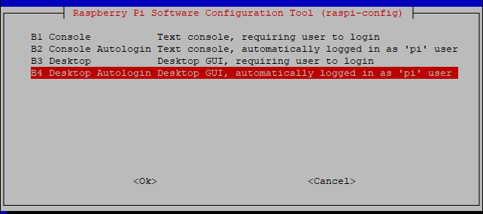

**TFT DRIVER INSTALL**

<https://www.waveshare.com/wiki/3.5inch_RPi_LCD_(A)#Method_1._Driver_installation>

**wget https://www.waveshare.com/w/upload/1/1e/LCD-show-180817.tar.gz**



**DRIVER extractor**

tar xvf LCD-show-180817.tar.gz

cd LCD-show/

chmod 777 LCD35-show

./LCD35-show

**SPI-LCD & TOUCH DRIVER INSTALL**

<https://www.raspberrypi.org/forums/viewtopic.php?t=175616>

sudo apt-get install xinput-calibrator

**CHROMIUM INSTALL**

sudo apt-get install unclutter  
sudo apt-get install xdotool

<https://raspberrypi.stackexchange.com/questions/374/how-do-i-install-google-chrome>

sudo apt-get install chromium-browser

**CHROMIUM AUTO START SETTING**

<https://www.raspberrypi.org/forums/viewtopic.php?t=163316>

sudo nano ~/.config/lxsession/LXDE-pi/autostart

sudo -u pi chromium-browser --kiosk --incognito http://127.0.0.1 &

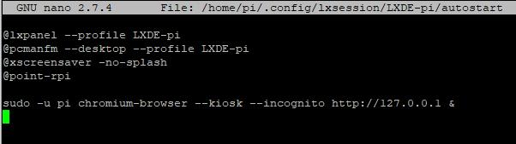

sudo reboot

